
BACHELOR OF COMPUTER SCIENCE (SOFTWARE ENGINEERING)

COURSE NAME AND CODE:
CSE3023 – WEB-BASED APPLICATION DEVELOPMENT (K1)

LAB 7

SEMESTER II SESSION 2025/2026

PREPARED BY:
NAME: AINAA NADHIRAH BINTI ASMADI
MATRIC NUMBER: S75246

COURSE LECTURER:
DR. WAN NURAL JAWAHIR BINTI HJ WAN YUSSOF

LAB MODERATOR:
PN. WAN FATIN FATIHAH BINTI YAHYA

LAB 7
Lab Exercise:
Output:
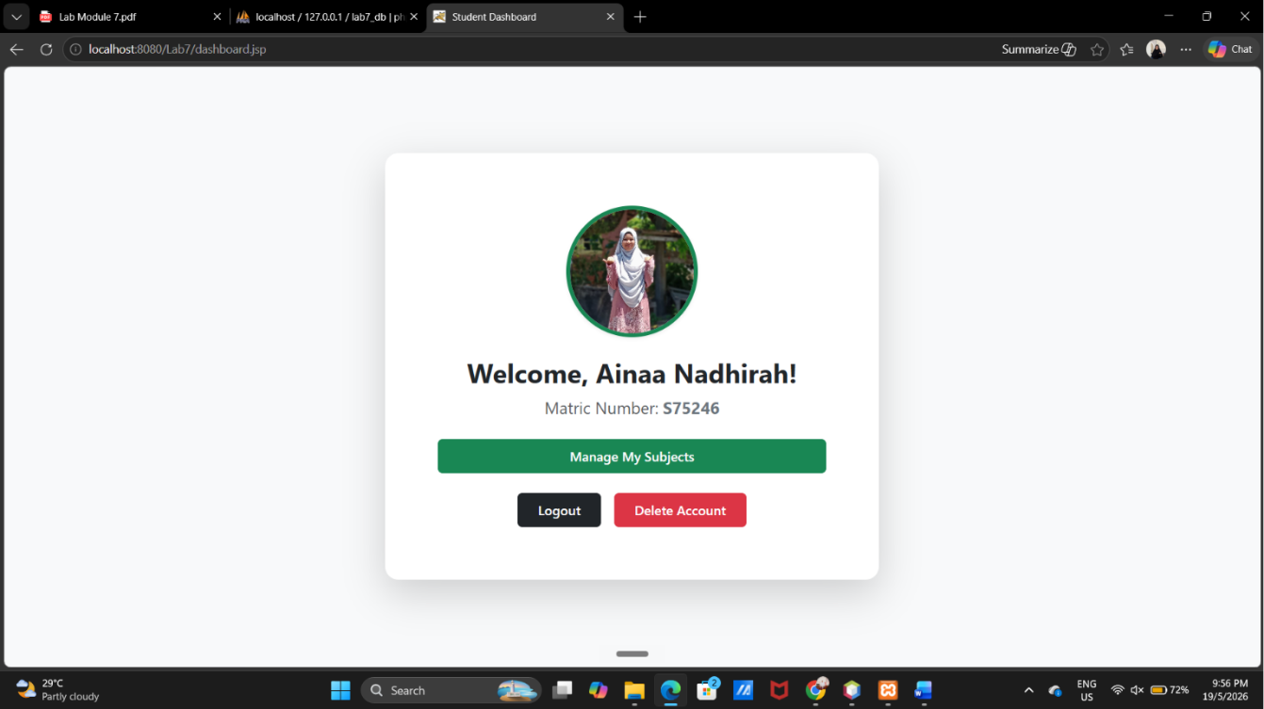

After click Manage My Subjects:
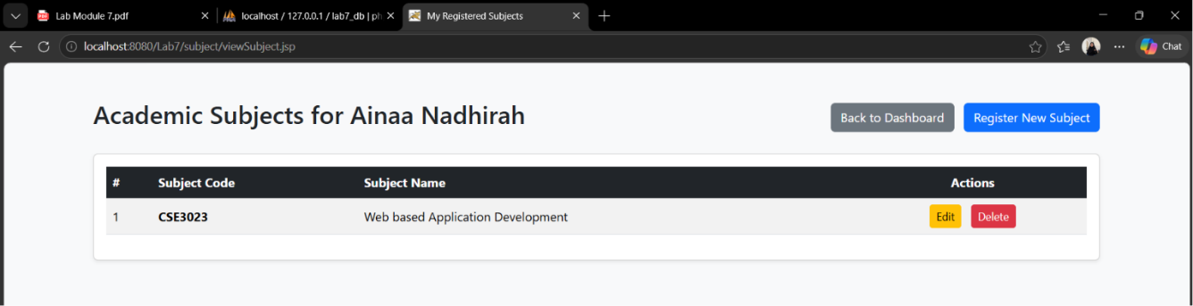

After Register new Subject:
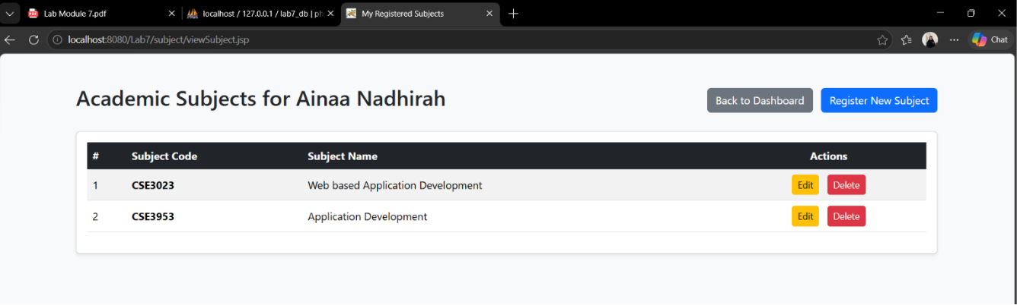

After click “Delete”
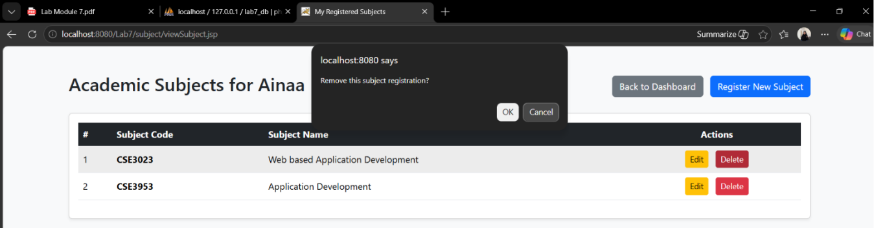

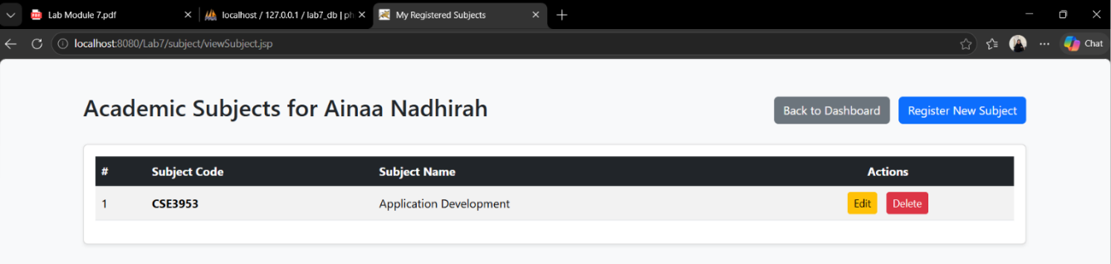

After click “Edit”
